|  |
| --- |
|  |
| **Face finder:** |  |
| Hey friend! I'm so excited that we get to work on this project together. It's going to be a lot of fun and a great challenge too. We're going to use machine learning models and code animated effects for the face filter, which will add cartoon eyes onto our faces in real time from the webcam video feed. This is such an awesome opportunity - let's make it happen! | |

|  |
| --- |
|  |

|  |  |
| --- | --- |
|  |  |

|  |  |
| --- | --- |
|  |  |
| **Face lock:**  to use This project is a really cool and innovative waymachine learning! You will be able to train a model that can recognize your face, so it only unlocks the phone for you. It's an exciting challenge that will help you learn more about how machine learning works and how it can be used in real life applications. Plus, once it's done, you'll have a great new feature on your virtual phone! | |

**Mil man Max:**This project is a great way to utilize the postcode system and help make mail delivery more efficient. You'll be training a computer to recognize the different codes at the start of postcodes, so that it can effectively sort letters into vans going to their respective sorting offices. It will no doubt be an interesting challenge, but one that should have positive outcomes for those using postal services in your area!

**Car or cup:**

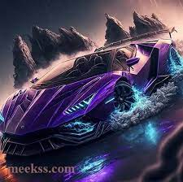This project is a great opportunity to learn how to train computers and create something unique. You will be able to teach the computer how to sort photos into two sets, one for cars and one for cups. It's an exciting challenge that

Analyzes data to find patterns in transportation choices

intelligence while having fun at the same time! Plus, it'll give you a chance to show off your creativity as well. Good luck with this project!

**Explainable Ai:**

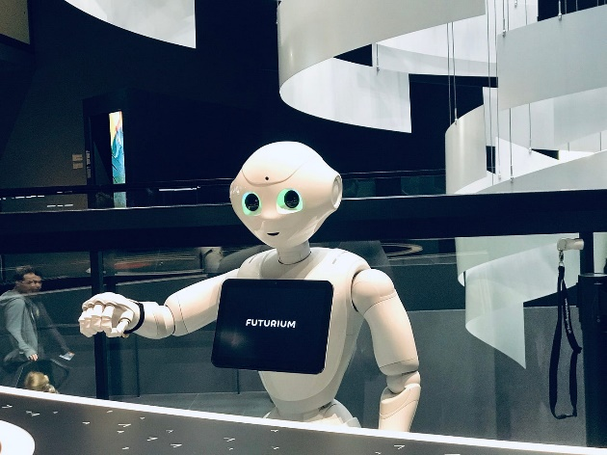It's amazing how far machine learning has come in being able to identify what is in an image. However, it can be difficult to understand why the model gives the answers that it does. With this project, you'll have a great opportunity to learn more about how these models work and gain insight into why they give certain answers when presented with images. You will use Scratch and other tools to create a tool which helps explain what parts of an image led your machine learning model towards its answer - making understanding easier than ever befor

**Hand gestures:**

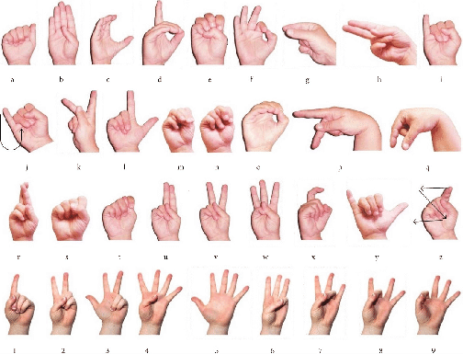Train computer to recognize hand gestures.

Assemble machine learning models to identify hand shape in webcam

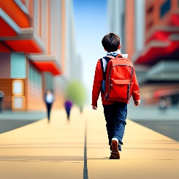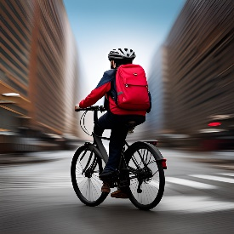**Journey to school:**

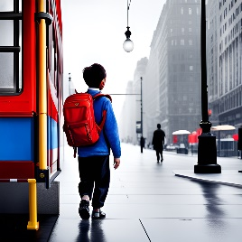Computer learns to predict how classmates get to school.

Analyzes data to find patterns in transportation choices